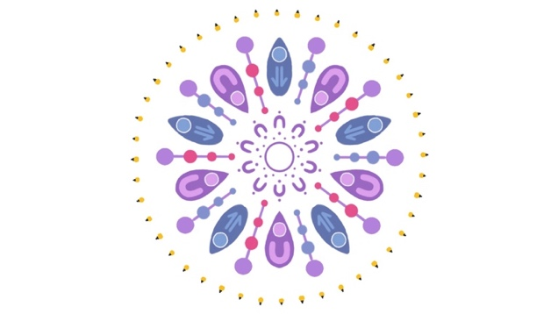 | Women’s Health Circle  Dr Cecelia O’Brien  Oxford Medical Suites  Level 1, Suite 4  18 Oxford Street Hyde Park Qld 4812  Email: admin@womenshealthcircle.com.au  Phone: 07 44261870 Fax: 07 44261873

PATIENT DETAILS
Name |  | Date of Birth
Address |  | Mobile Phone
History |  | LMP  EDC  EDC based on | ____/_____/_____  ____/_____/_____  LMP or Dating scan ___ wks  or Embryo transfer

REFERRER DETAILS
Name |  | Signature
Copy to |  | Date

SERVICES (Please tick)
Obstetric |  | Gynaecology
 | Dating/viability scan with pregnancy planning for GP |  | Pre-pregnancy counselling
 | Cell free DNA plus structural scan (10 – 16 wks) Includes viability scan on the day, pre and post-test counselling, collection of sample |  | Carrier screening including pre and post-test counselling and collection
 | Combined first trimester screening (11+0 - 13+6 wks)  (Please ensure PAPPA/BHCG are done at 11 weeks) |  | Pelvic ultrasound including TVUSS and 3D reconstruction
 | Additional Pre-eclampsia screening (12 – 14 wks) |  | Mirena insertion or removal
 | Tertiary morphology scan (2nd opinion, 18 – 22 wks) |  | HysteroContrastSalpingography (HyCoSy)
 | Cervical screening from 16 weeks onwards |  | Sonohysterogram
 | Multiple pregnancy growth and wellbeing |  | Ovarian follicle tracking
 | Fetal growth and wellbeing (> 22 wks) |  | Deep infiltrating endometriosis ultrasound
 | Amniotic fluid and Doppler studies |  | Implanon removals under USS guidance

* Could you please also send a Specialist referral letter with any relevant clinical history, blood or imaging results
for my Consultation along with our imaging referral form.

